Applied Physics Assignment-2

Force and Newton’s Law
- A ball of mass m1= 5kg and a block of mass m2= 13kg are attached by a lightweight cord that passes over a frictionless pulley of negligible mass, as shown in Figure-1. The block lies on a frictionless incline of angle(θ = 48⁰). Find the magnitude of the acceleration of the two objects and the tension in the cord.
- When two objects of unequal mass are hung vertically over a frictionless pulley of negligible mass. Determine the magnitude of the acceleration of the two objects and the tension in the lightweight cord. m1 = 4kg and m2 =9.5kg
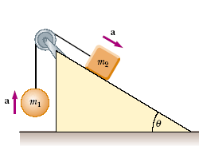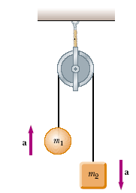
Fig-1 Fig-2
- A baseball player with mass 79kg, sliding into a base is slowed by a force of friction of 470N. What is the coefficient of kinetic friction between the player and the ground?
- The coefficient of static friction between the tires of a car and a dry road is 0.62. The mass of the car is 1500kg.What maximum braking force is obtainable (a) on a level road and (b) on an 8.6º downgrade?
- A hockey puck having a mass of 0.50 kg slides on the horizontal, frictionless surface of an ice rink. Two forces act on the puck, as shown in Figure-3. The force F1 has a magnitude of 3.5.0 N, and the force F2 has a magnitude of 7.5.0 N. Determine both the magnitude and the direction of the puck’s acceleration.
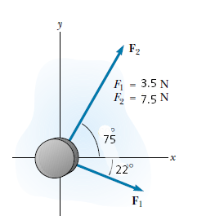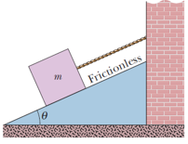
Fig-3 Fig-4

- In Fig. 4 let the mass of the block be 8.5 kg and the angle be 30.Find (a) the tension in the cord and (b) the normal force acting on the block. (c) If the cord is cut, find the magnitude of the resulting acceleration of the block.

- In the following Figure-5, a block of mass = 3.0 kg slides along a floor while a force F of magnitude 12.0 N is applied to it at an upward angel ϴ. The coefficient of kinetic friction between the block and the floor is μ = 0. 40. (We can vary ϴ from 0 to 90, but block still remain on the floor). What vale of ϴ gives the maximum value of the lock’s acceleration magnitude “a” ? Calculate.
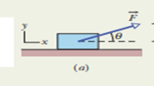 Fig-5

Oscillation

- An object undergoing simple harmonic motion takes 0.25 s to travel from one point of zero velocity to the next such point. The distance between those points is 36 cm. Calculate the (a) period, (b) frequency, and (c) amplitude of the motion.
- A 0.12 kg body undergoes simple harmonic motion of amplitude 8.5 cm and period 0.20 s. (a) What is the magnitude of the maximum force acting on it? (b) If the oscillations are produced by a spring, what is the spring constant?
- A particle with a mass of 1.00 kg is oscillating with simple harmonic motion with a period of 1.00 s and a maximum speed of 1.00 103 m/s. Calculate (a) the angular frequency and (b) the maximum displacement of the particle.
- What is the phase constant for the harmonic oscillator with the position function x(t) given in Fig. 1 if the position function has the form x = xm cos(ɷt + φ )? The vertical axis scale is set by xs 6.0 cm.
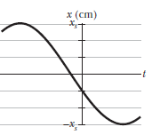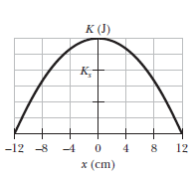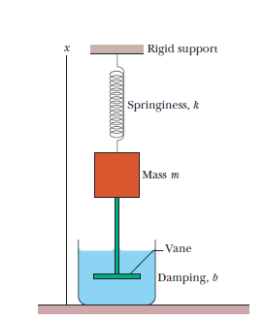
Fig-1 Fig-2 Fig-3

- Figure 2 shows the kinetic energy K of a simple harmonic oscillator versus its position x. The vertical axis scale is set by Ks = 4.0. What is the spring constant.
- For the damped oscillator system shown in Fig.3 , the block has a mass of 1.50 kg and the spring constant is 8.00 N/m. The damping force is given by -b(dx/dt), where b = 230g/s. The block is pulled down 12.0 cm and released. (a) Calculate the time required for the amplitude of the resulting oscillations to fall to one-third of its initial value. (b) How many oscillations are made by the block in this time?

- The position function x = (6.0 m) cos[(3π rad/s)t + π/3 rad] gives the simple harmonic motion of a body. At t = 2.0 s, what are the (a) displacement, (b) velocity, (c) acceleration, and (d) phase of the motion? Also, what are the (e) frequency and (f) period of the motion?
- A 3.0 kg particle is in simple harmonic motion in one dimension and moves according to the equation x = (5.0 m) cos[(π /3 rad/s)t + π /4 rad], with t in seconds. (a) At what value of x is the potential energy of the particle equal to half the total energy? (b) How long does the particle take to move to this position x from the equilibrium position?
- A 5.00 kg object on a horizontal frictionless surface is attached to a spring with k 1000 N/m. The object is displaced from equilibrium 50.0 cm horizontally and given an initial velocity of 10.0 m/s back toward the equilibrium position. What are (a) the motion’s frequency, (b) the initial potential energy of the block–spring system, (c) the initial kinetic energy, and (d) the motion’s amplitude.
- For the damped oscillator of Fig. 3, m = 80Kg, k= 85 N/m, and b = 4kg/s.
(a) What is the period of the motion? How long does it take for the amplitude of the damped oscillations to drop to half its initial value? How long does it take for the mechanical energy to drop to one-half its initial value?

